**REFERENCES**

1. BALASAHEB PHALKE, B., LONDHE, V., & ARUDKAR, A. 2020. *A Poultry Farm* Management System. *International Journal of Research in Engineering, Science and Management*, *3*(7), 41–43. https://bit.ly/41f8PIX
2. CHEN, H.Q. & XIN, HONGWEI & TENG, G.H. & MENG, C.Y. & DU, XIAODONG & MAO, T.T. & WANG, C.. 2016. *Cloud-based data management system for automatic real-time data acquisition from large-scale laying-hen farms.* 9. 106-115. <https://tinyurl.com/bdz5knnn>
3. NDUANYA, UJUNWA & OKOYE, FRANCIS & NDUBUISI JOHN, NGENE. 2020. *Online Building Materials Inventory System*. 07. 80-97. <https://tinyurl.com/3x4svc66>
4. GASCON, S.T. 2019. *BIYAYA: A Web-Based Agricultural Management System. Proceedings of International Conference on Techonological Challenges for Better World 2019.* <https://bit.ly/44D37mW>
5. AMOR, R. 2018. *Computerized Sales And Inventory System of 2M Trading.* https://bit.ly/3nC5K85

[6] REBORTERA, MARIANNIE. 2021. *e-VaccIMS: A Web-Based Vaccine Inventory Management In The Health Office Entrenching Forecasting Algorithm.* <https://tinyurl.com/2tdpdtxz>

**APPENDICES**

**APPENDIX A. TRANSMITTAL LETTERS**

**Appendix A. Transmittal Letters**

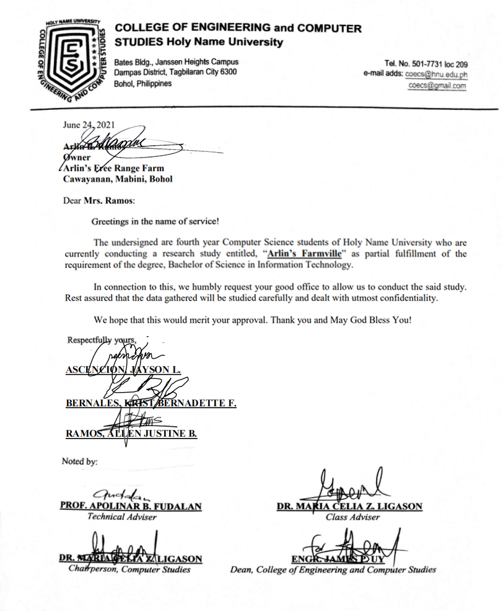

**APPENDIX C.**

**SAMPLE INPUT/OUTPUT REPORTS**

**Appendix C. Sample Input/Output Reports**

1. **Login**

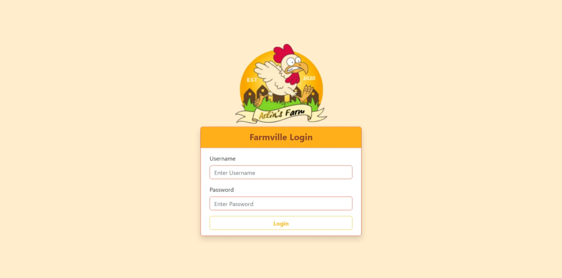

1. **Manage Chicken Production**
2. Add Chicken Allocation

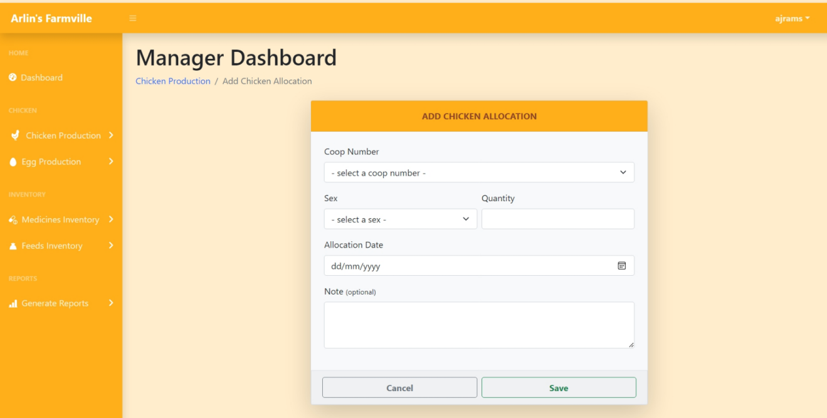

1. Update Chicken Record

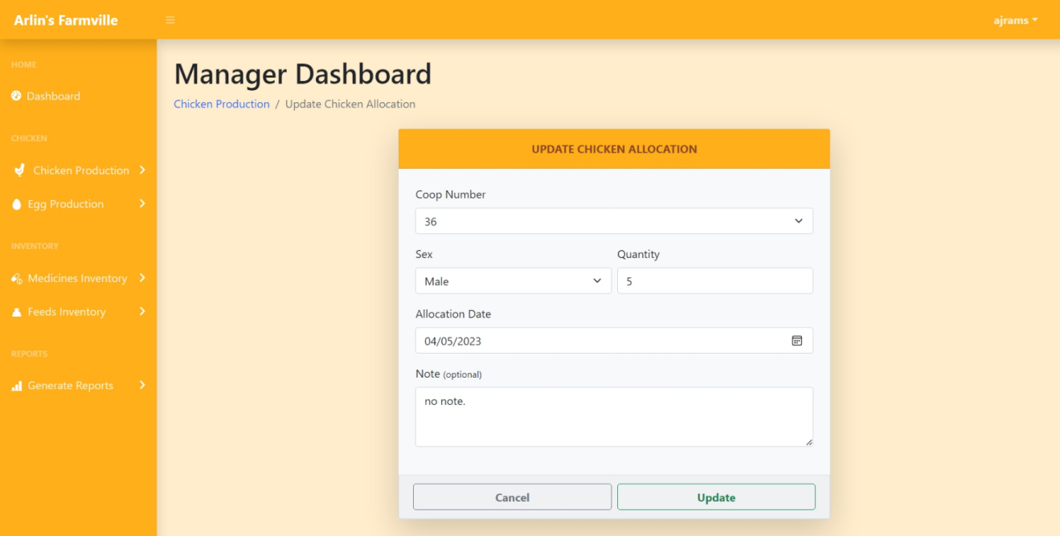

1. View Chicken Record

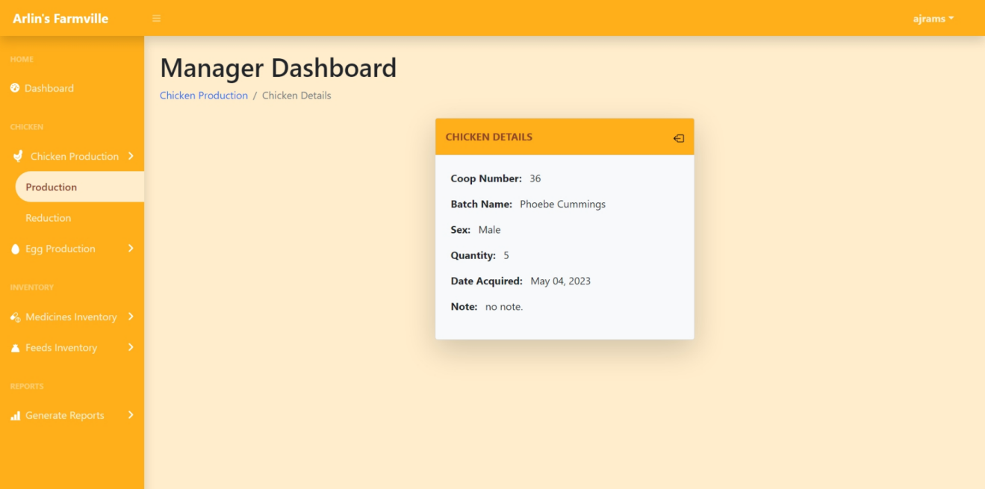

1. Archive Chicken Record

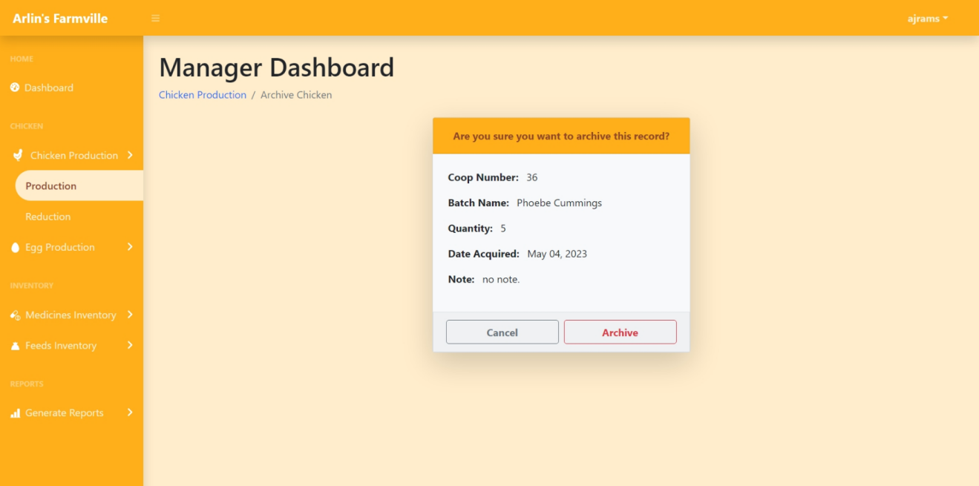

1. Add Chicken Reduction

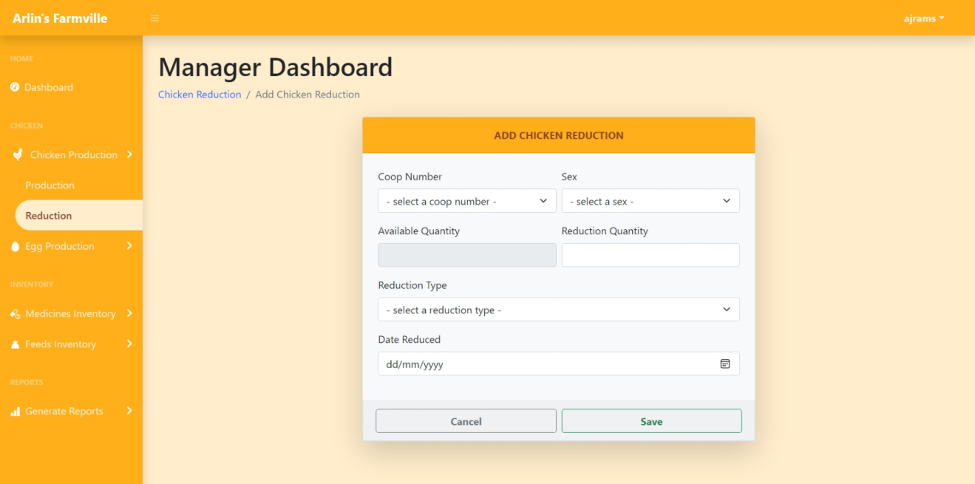

1. **Manage Egg Production**
2. Egg Production Table

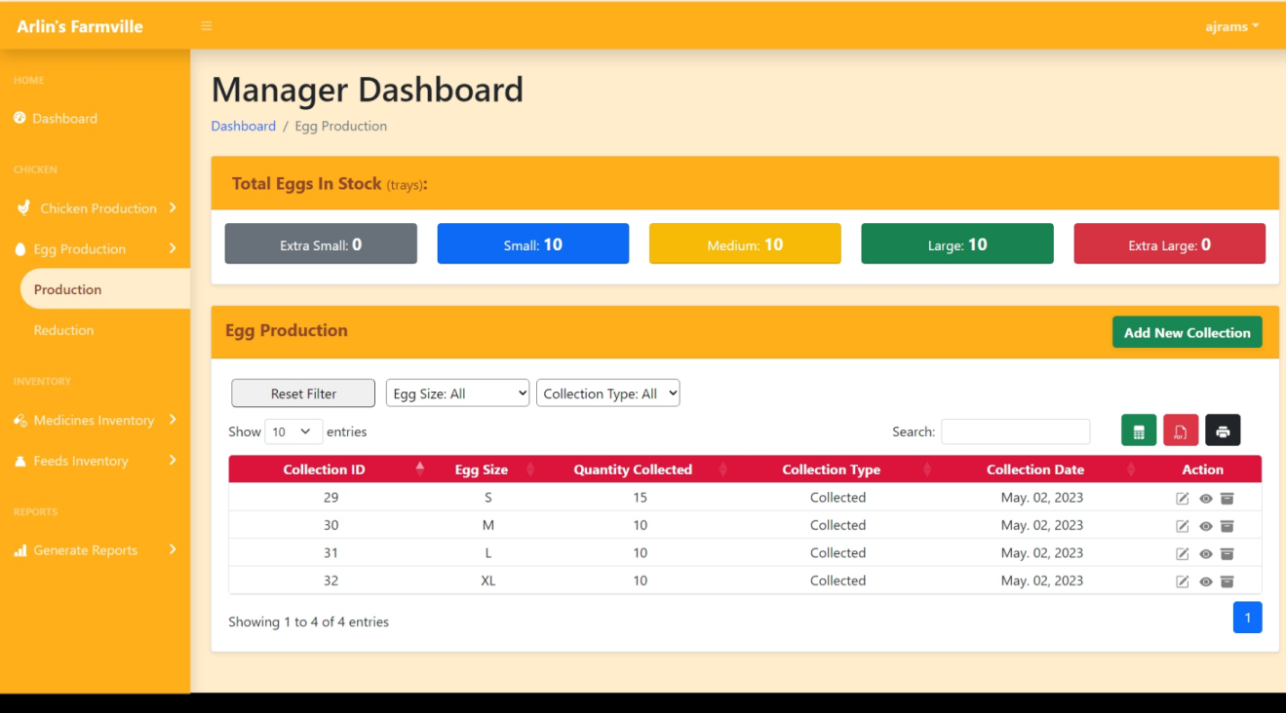

1. Add Egg Collection

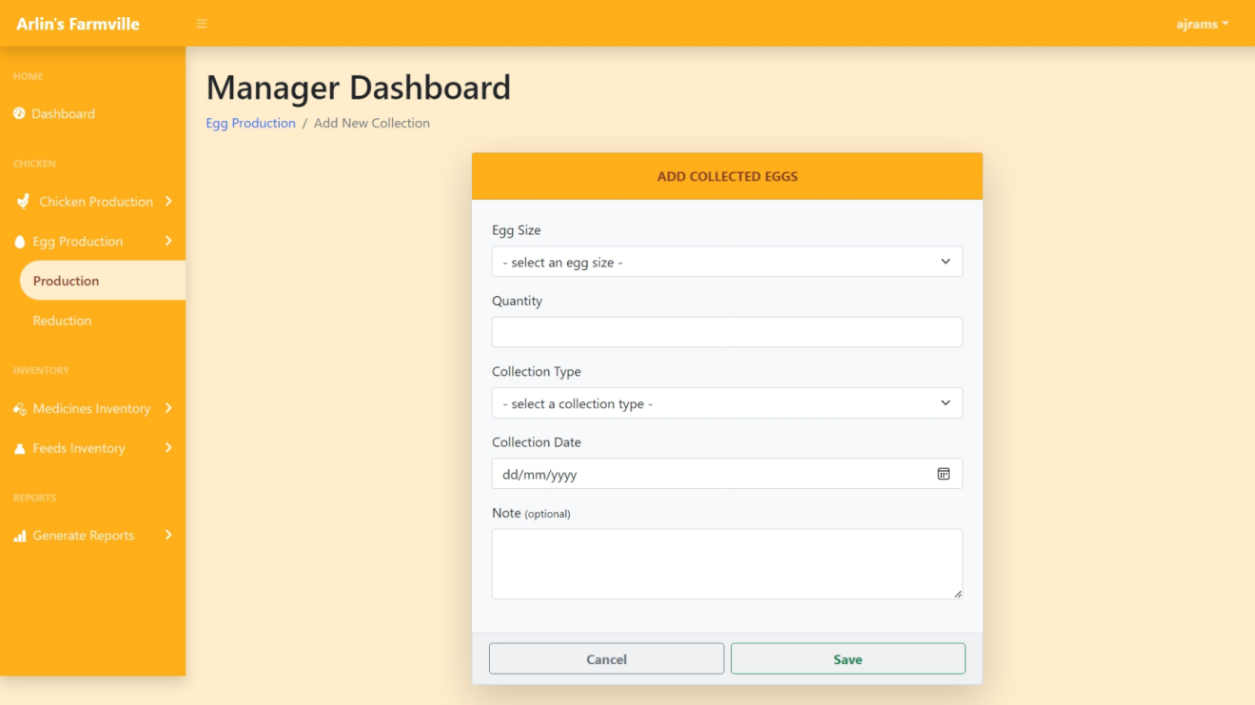

1. Update Egg Collection

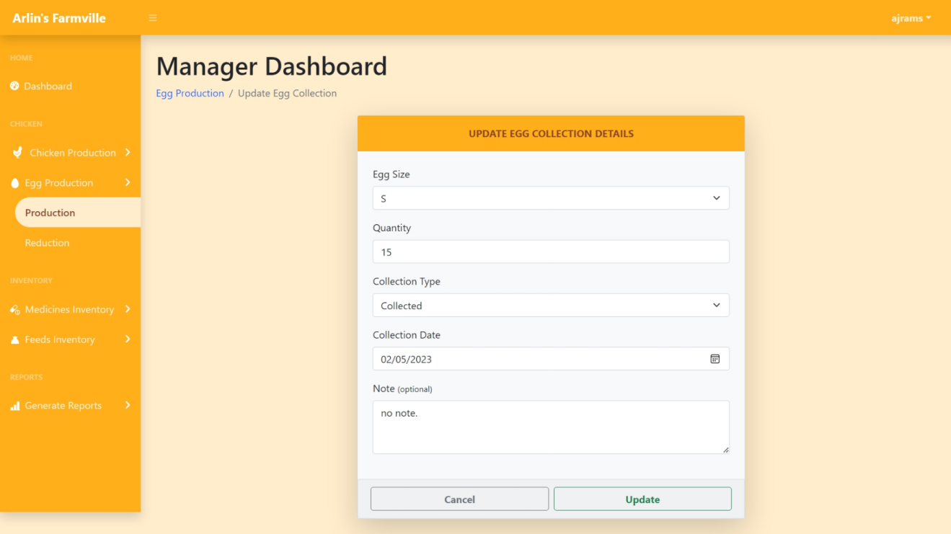

1. View Egg Collection

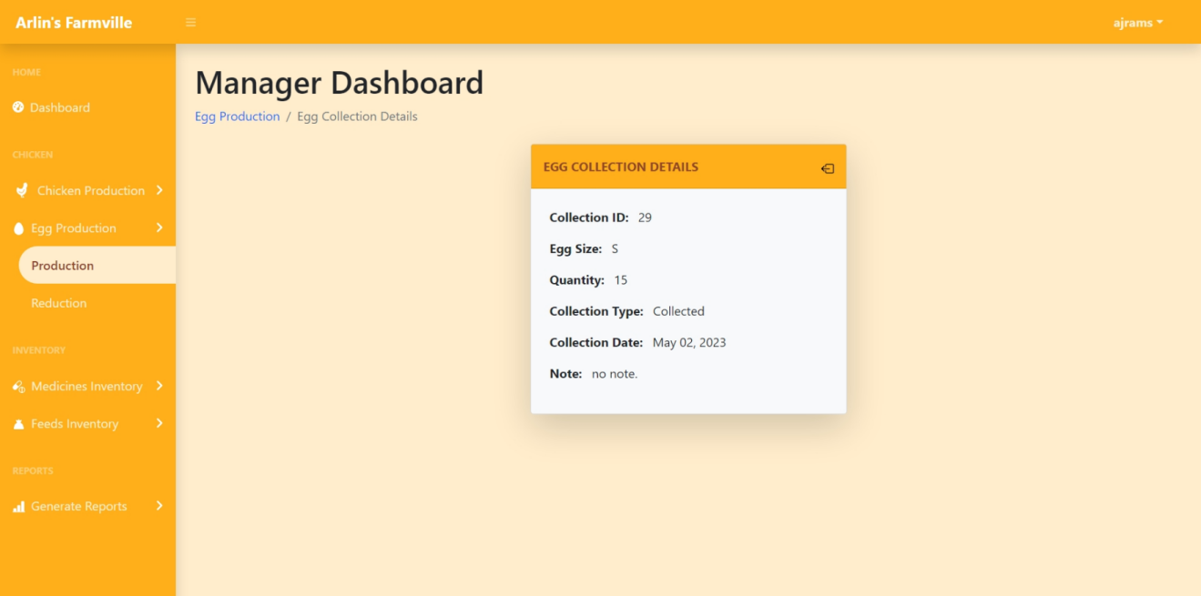

1. Archive Egg Collection

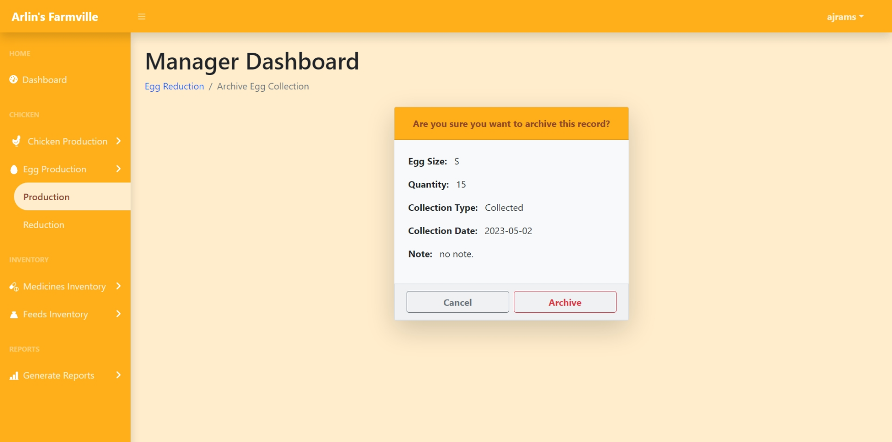

1. Add Egg Reduction

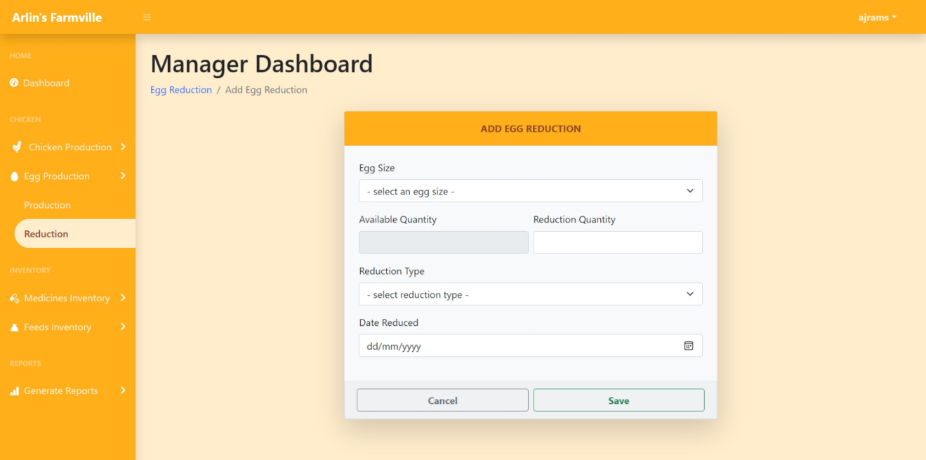

1. **Manage Farm Inventory**
2. List of Medicines

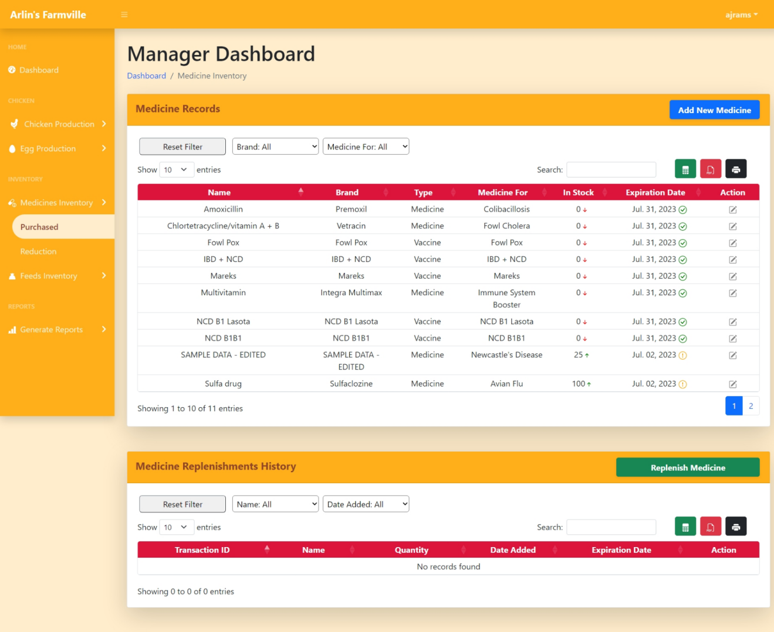

1. Replenish Medicine

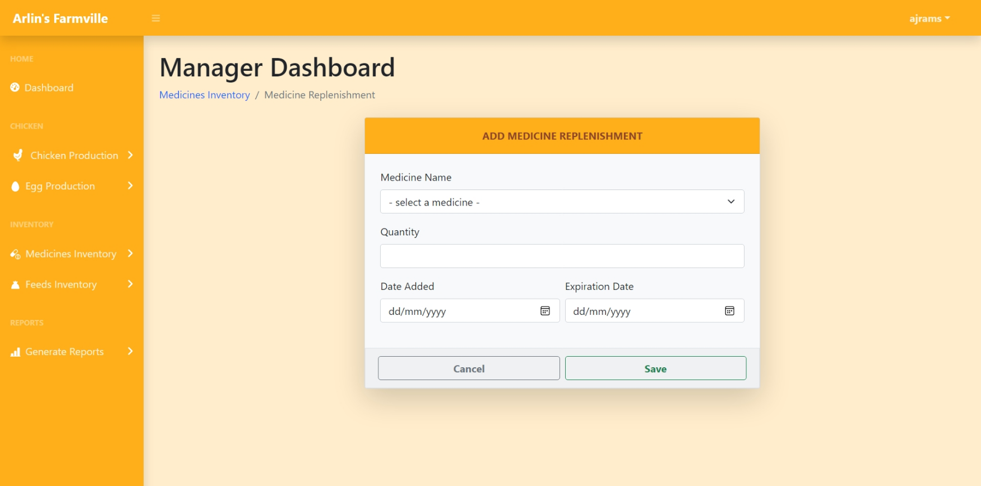

1. Update Medicine Record



1. View Medicine Record

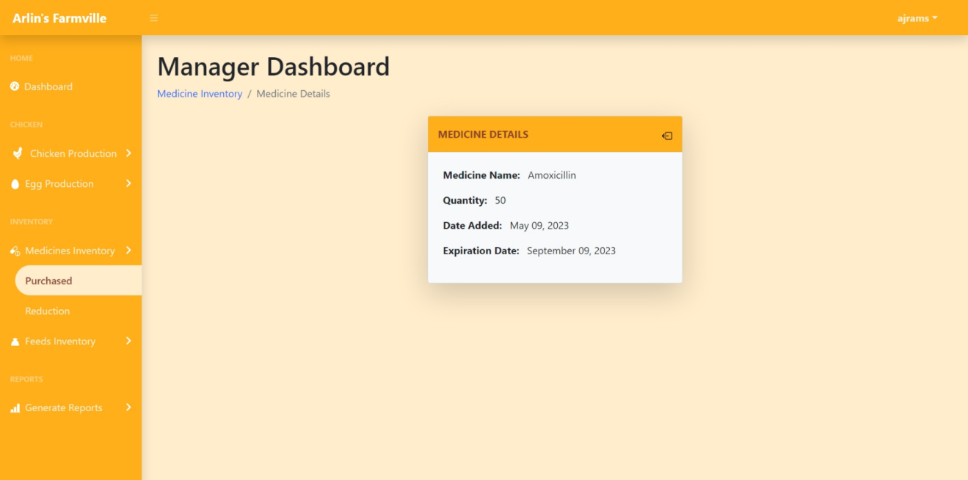

1. Archive Medicine Record

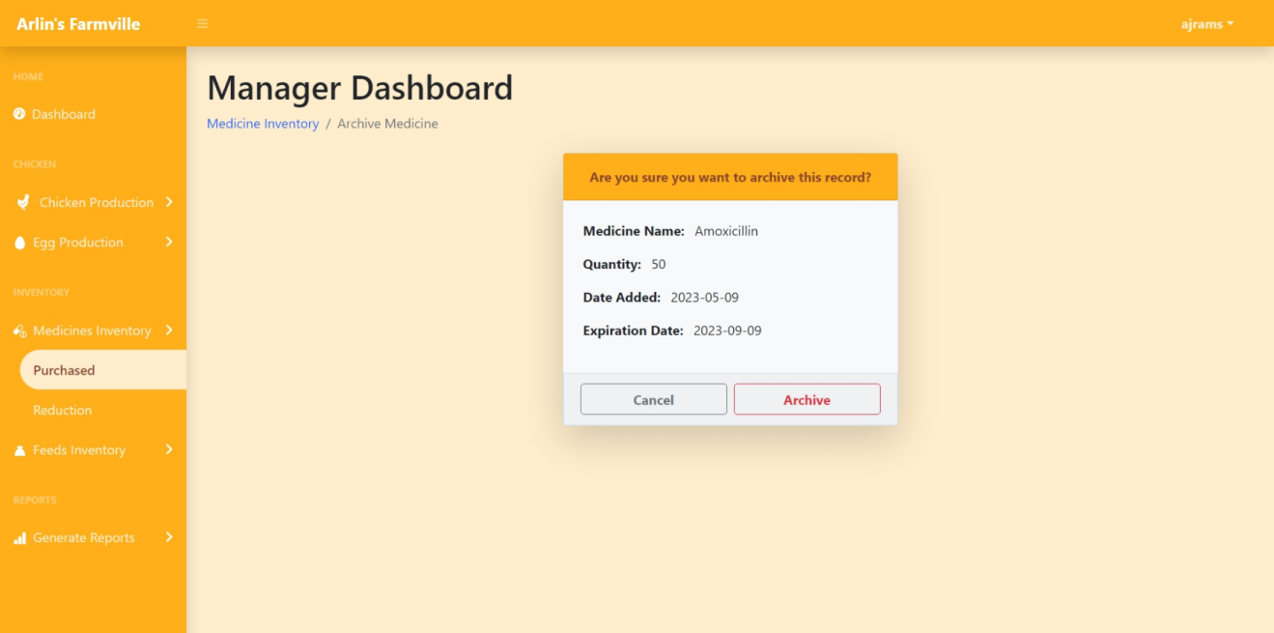

1. Add Medicine Reduction

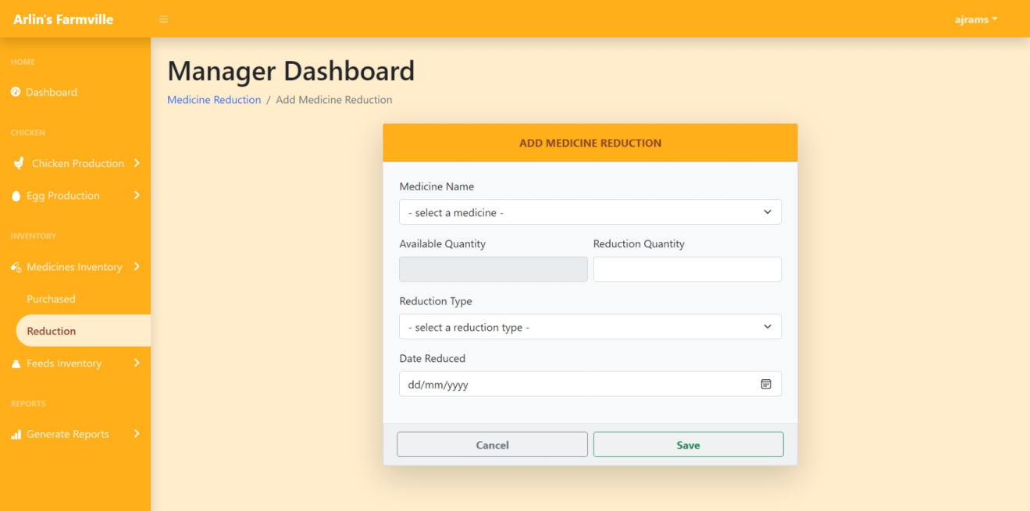

1. **Manage Medicine Administration**
2. List of Schedules

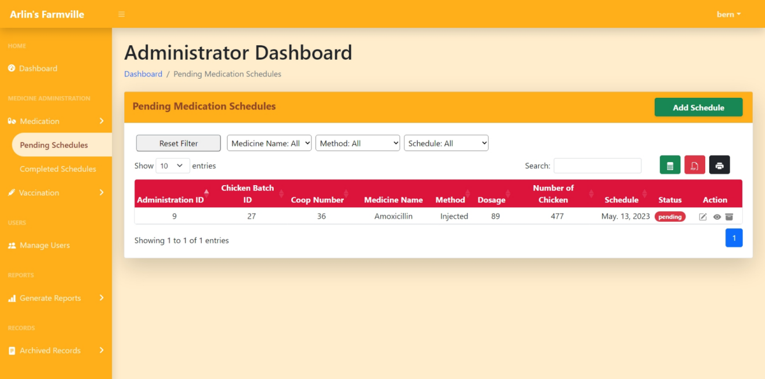

1. Add New Schedule

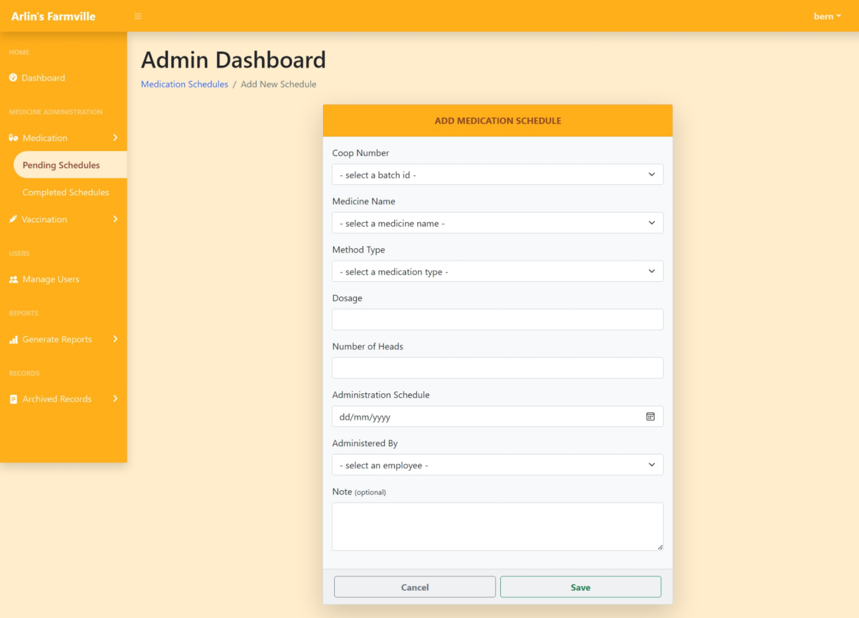

1. Update Schedule

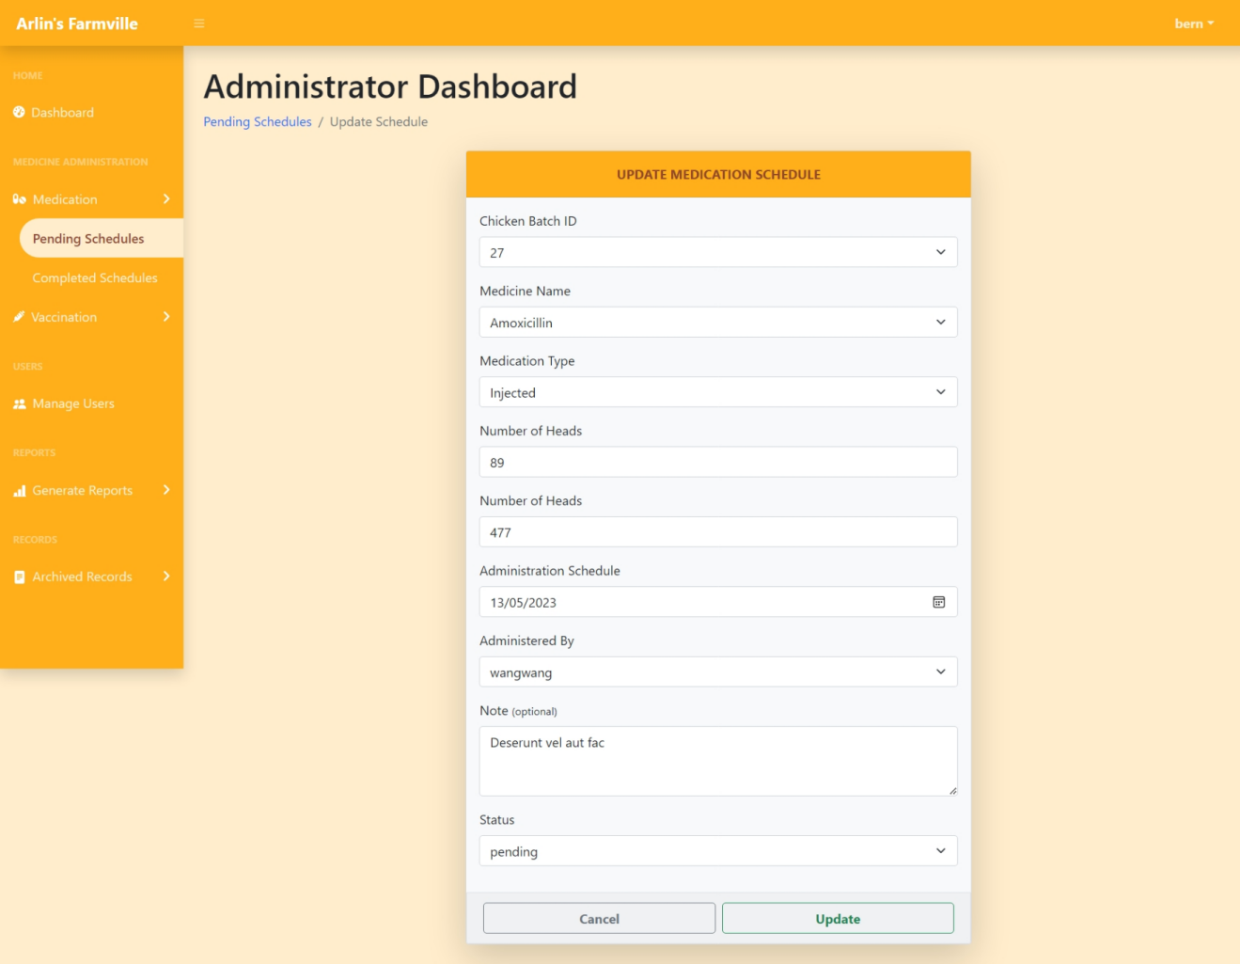

1. View Schedule

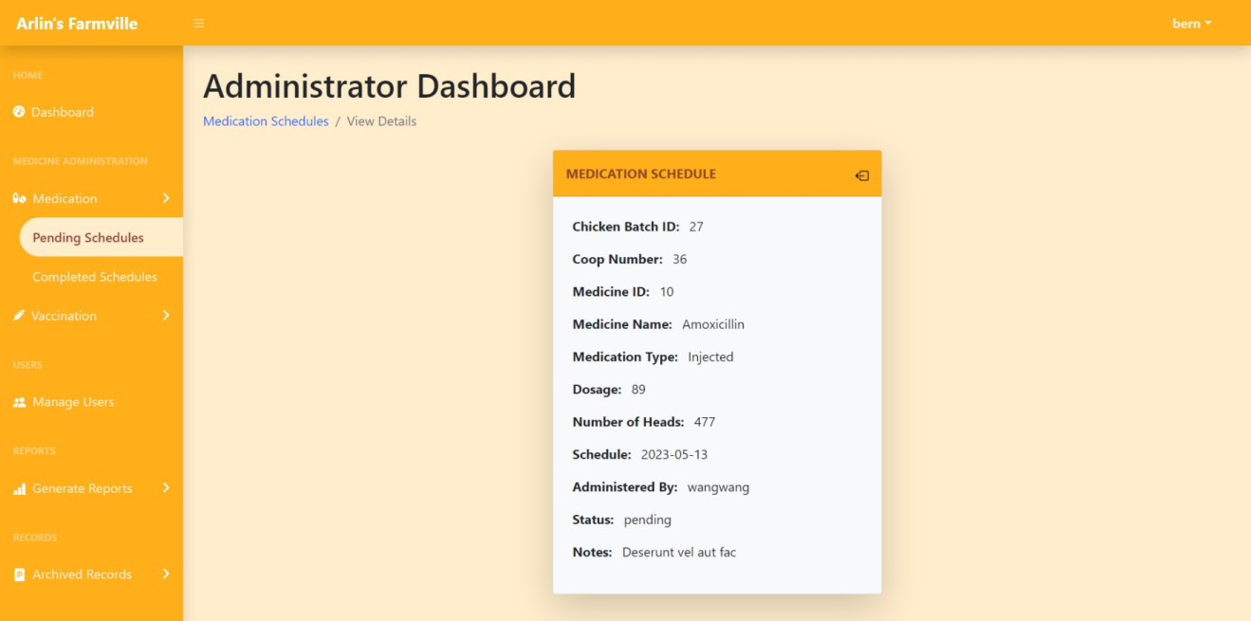

1. Archive Schedule

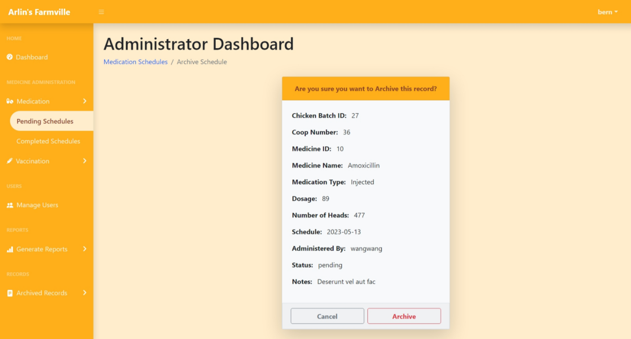

1. **Manage Farm User**
2. Farm Users List



1. Add New User

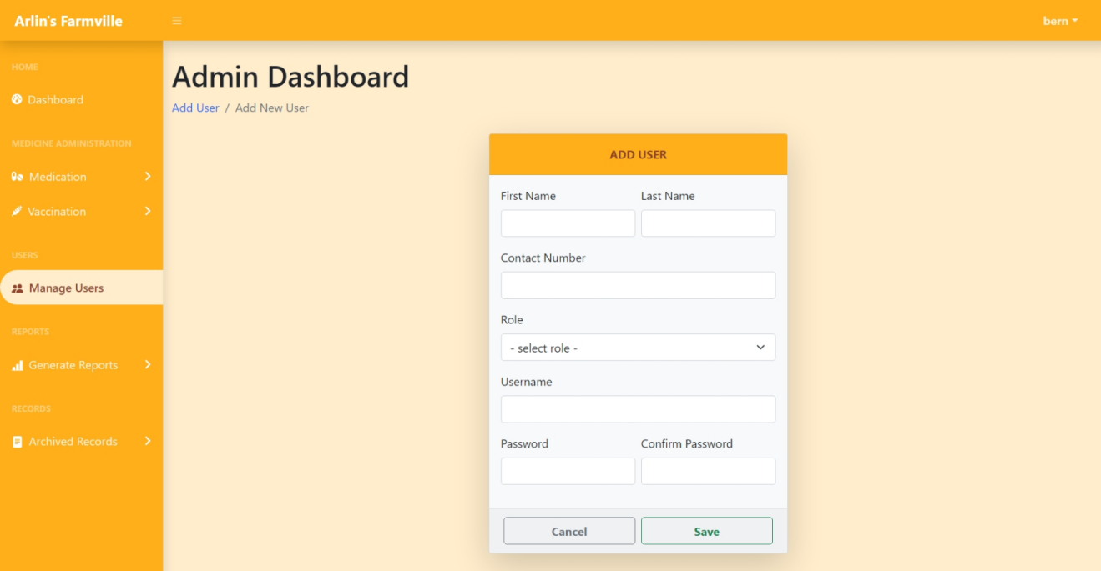

1. Update User

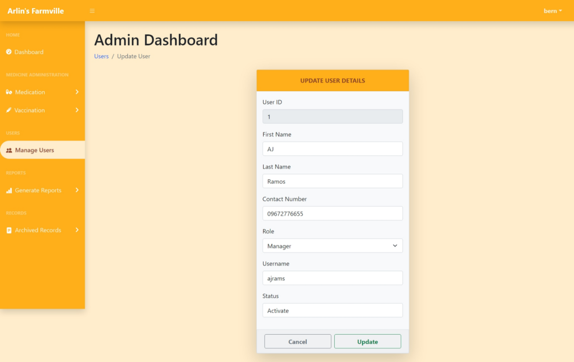

1. View User

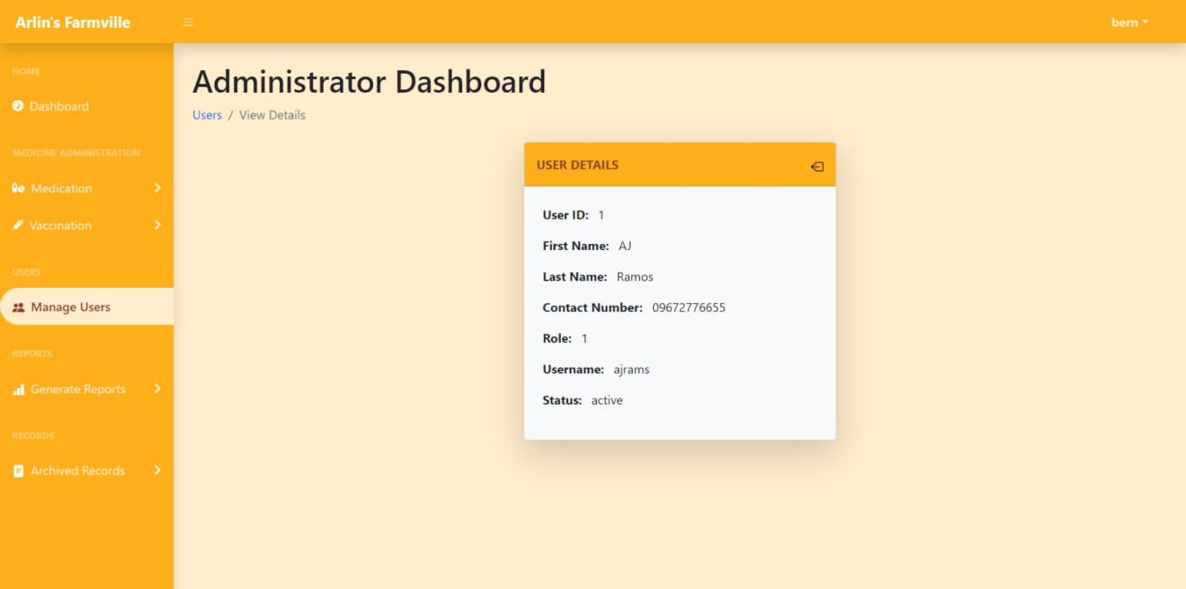

1. **Manage Archived Records**
2. List of Archived Records

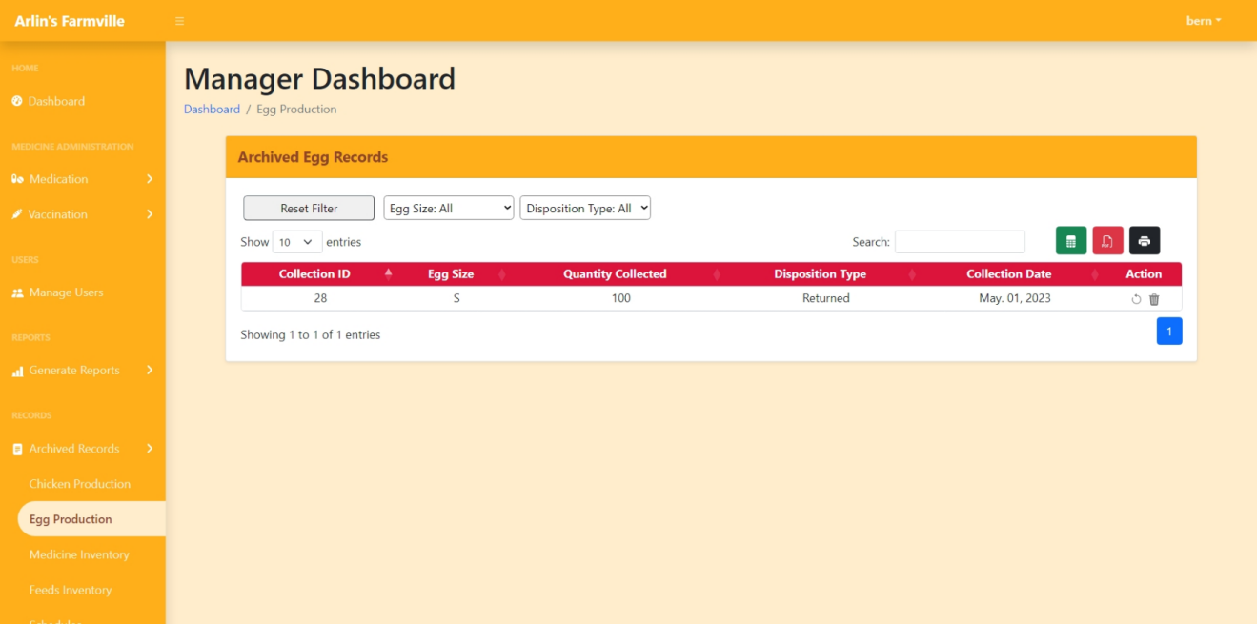

1. Restore Record

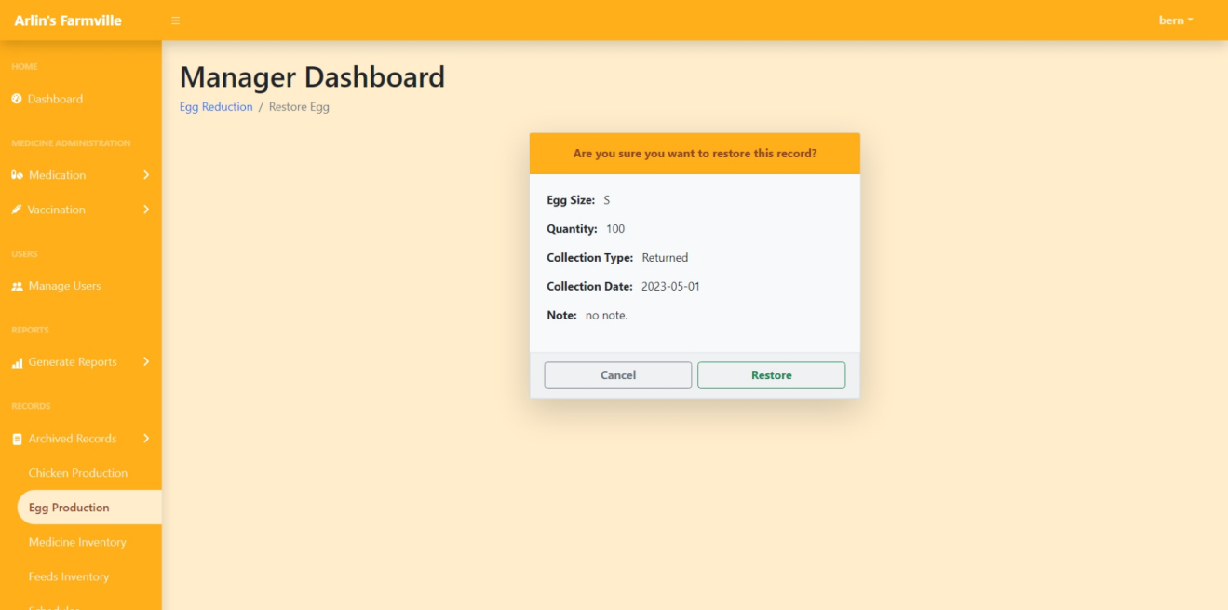

1. Delete Record

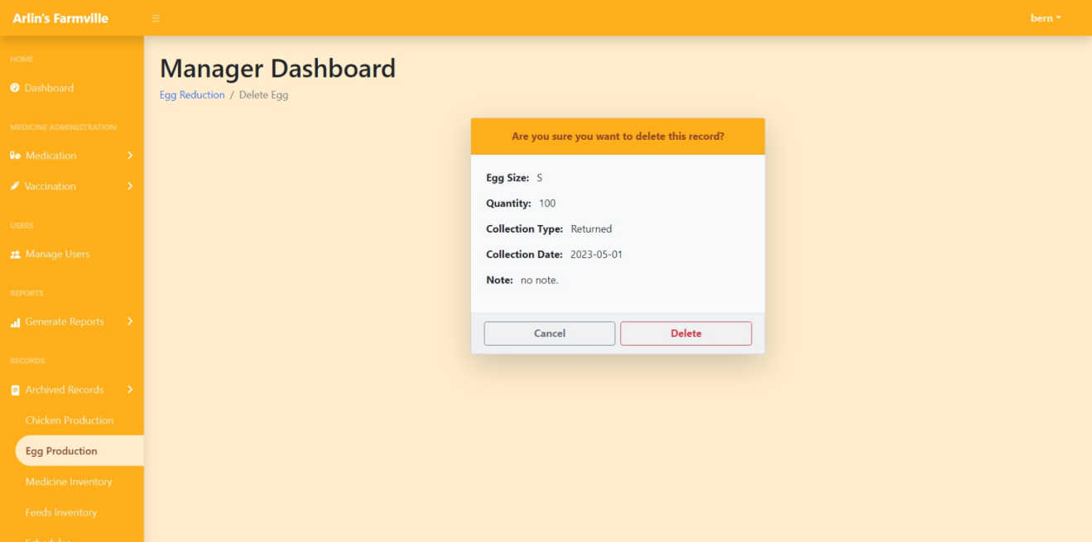

1. **Generate Reports**
2. Pick a date

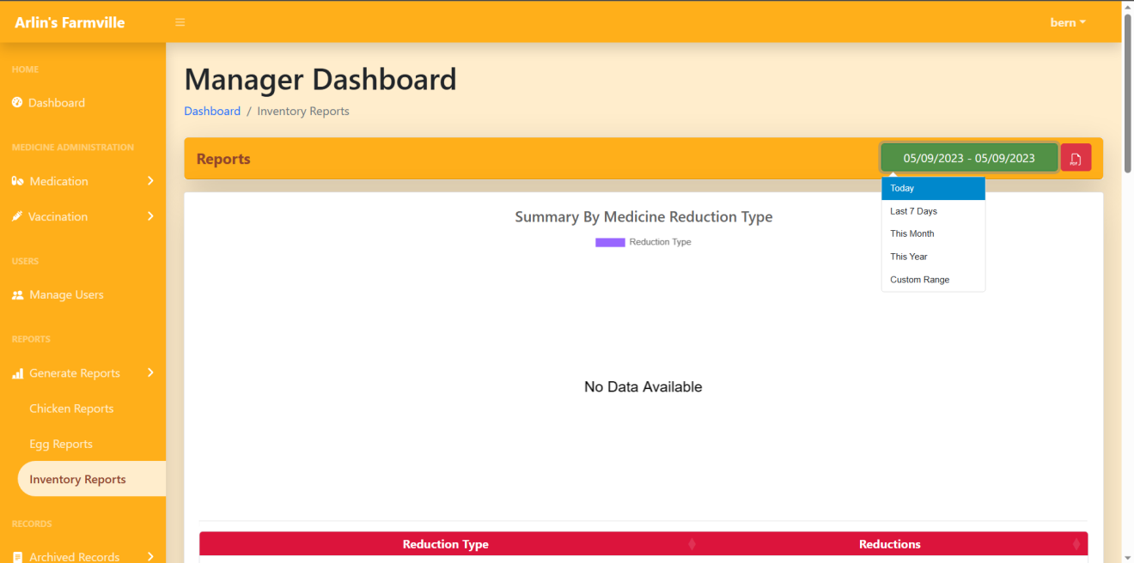

1. Generate Report

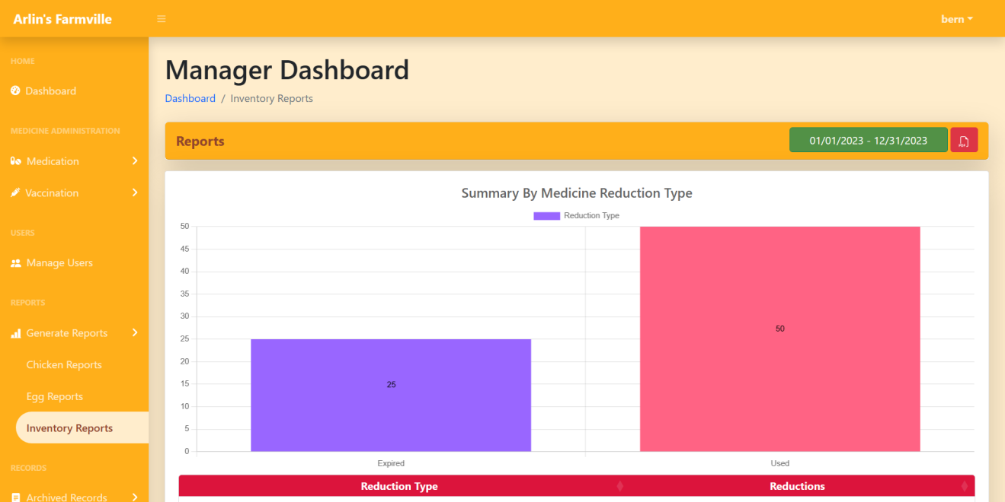

**Appendix D. User Guide**

**ARLIN’S FARMVILLE**

1. **System Login**
2. Enter matching username and password
3. Click the Log In button
4. **Manage Chicken Production**
5. **Add New Coop**
6. Click Chicken Production
7. Click Production
8. Click Add New Coop Button
9. Enter coop information
10. Click Save Button
11. **Add Chicken Allocation**
12. Click Chicken Production
13. Click Production
14. Click Add Chicken Allocation Button
15. Enter chicken allocation information
16. Click Save Button
17. **Update Chicken Record**
18. Click Chicken Production
19. Click Production
20. Click Update Icon
21. Edit chicken information
22. Click Update Button
23. **View Chicken Record**
24. Click Chicken Production
25. Click Production
26. Click Eye/View Icon
27. **Archive Chicken Record**
28. Click Chicken Production
29. Click Production
30. Click Delete/Trash Icon
31. Click Archive Button
32. Click Yes Button
33. **Add Chicken Reduction**
34. Click Chicken Production
35. Click Reduction
36. Click Add Reduction
37. Enter reduction information
38. Click Save Button
39. **Update Reduction**
40. Click Chicken Production
41. Click Reduction
42. Click Update Icon
43. Edit reduction information
44. Click Save Button
45. **View Reduction**
46. Click Chicken Production
47. Click Reduction
48. Click Eye/View Icon
49. **Delete Reduction**
50. Click Chicken Production
51. Click Reduction
52. Click Delete/Trash Icon
53. Click Delete Button
54. Click Yes Button
55. **Manage Egg Production**
56. **Add New Collection**
57. Click Egg Production
58. Click Production
59. Click Add New Collection Button
60. Enter collection information
61. Click Save Button
62. **Update Collection**
63. Click Egg Production
64. Click Production
65. Click Update Icon
66. Edit collection information
67. Click Save Button
68. **View Collection**
69. Click Egg Production
70. Click Production
71. Click Eye/View Icon
72. **Archive Collection**
73. Click Egg Production
74. Click Production
75. Click Trash/Delete Icon
76. Click Archive Button
77. Click Yes Button
78. **Add Egg Reduction**
79. Click Egg Production
80. Click Reduction
81. Click Add Reduction
82. Enter reduction information
83. Click Save Button
84. **Update Reduction**
85. Click Egg Production
86. Click Reduction
87. Click Update Icon
88. Edit reduction information
89. Click Update Button
90. **View Reduction**
91. Click Egg Production
92. Click Reduction
93. Click Eye/View Icon
94. **Delete Reduction**
95. Click Egg Production
96. Click Reduction
97. Click Trash/Delete Icon
98. Click Delete Button
99. Click Yes Button
100. **Manage Farm Inventory**
101. **Add New Medicine**
102. Click Medicine Inventory
103. Click Purchased
104. Click Add New Medicine Button
105. Enter medicine information
106. Click Save Button
107. **Replenish Medicine**
108. Click Medicine Inventory
109. Click Purchased
110. Click Replenish Medicine Button
111. Enter replenishment information
112. Click Save Button
113. **Update Medicine Record**
114. Click Medicine Inventory
115. Click Purchased
116. Click Update Icon
117. Edit information
118. Click Update Button
119. **View Medicine Record**
120. Click Medicine Inventory
121. Click Purchased
122. Click Eye/View Icon
123. **Archive Medicine Record**
124. Click Medicine Inventory
125. Click Purchased
126. Click Trash/Delete Icon
127. Click Archive Button
128. Click Yes Button
129. **Add Medicine Reduction**
130. Click Medicine Inventory
131. Click Reduction
132. Click Add Reduction Button
133. Enter reduction information
134. Click Save Button
135. **Update Medicine Reduction**
136. Click Medicine Inventory
137. Click Reduction
138. Click Update Icon
139. Edit reduction information
140. Click Update
141. **View Medicine Reduction**
142. Click Medicine Inventory
143. Click Reduction
144. Click Eye/View Icon
145. **Delete Medicine Reduction**
146. Click Medicine Inventory
147. Click Reduction
148. Click Trash/Delete Icon
149. Click Delete Button
150. Click Yes Button
151. **Add New Feed**
152. Click Feed Inventory
153. Click Purchased
154. Click Add New Feed Button
155. Enter feed information
156. Click Save Button
157. **Replenish Feed**
158. Click Feed Inventory
159. Click Purchased
160. Click Replenish Feed Button
161. Enter replenishment information
162. Click Save Button
163. **Update Feed Record**
164. Click Feed Inventory
165. Click Purchased
166. Click Update Icon
167. Edit information
168. Click Update Button
169. **View Feed Record**
170. Click Feed Inventory
171. Click Purchased
172. Click Eye/View Icon
173. **Archive Feed Record**
174. Click Feed Inventory
175. Click Purchased
176. Click Trash/Delete Icon
177. Click Archive Button
178. Click Yes Button
179. **Add Feed Reduction**
180. Click Feed Inventory
181. Click Reduction
182. Click Add Reduction Button
183. Enter reduction information
184. Click Save Button
185. **Update Feed Reduction**
186. Click Feed Inventory
187. Click Reduction
188. Click Update Icon
189. Edit reduction information
190. Click Update
191. **View Feed Reduction**
192. Click Feed Inventory
193. Click Reduction
194. Click Eye/View Icon
195. **Delete Feed Reduction**
196. Click Feed Inventory
197. Click Reduction
198. Click Trash/Delete Icon
199. Click Delete Button
200. Click Yes Button
201. **Manage Medicine Administration**
202. **Add Schedule**
203. Click Medication
204. Click Pending Schedule
205. Click Add Schedule
206. Enter schedule information
207. Click Save Button
208. **Update Schedule**
209. Click Medication
210. Click Pending Schedule
211. Click Update Icon
212. Edit schedule information
213. Click Update Button
214. **View Schedule**
215. Click Medication
216. Click Pending Schedule
217. Click Eye/View Icon
218. **Archive Schedule**
219. Click Medication
220. Click Pending Schedule
221. Click Trash/Delete Icon
222. Click Archive Button
223. Click Yes Button
224. **Manage Farm User**
225. **Add New User**
226. Click Manage Farm Users
227. Click Add New User
228. Enter user information
229. Click Save Button
230. **Update User**
231. Click Manage Farm Users
232. Click Update Icon
233. Edit user information
234. Click Update Button
235. **View User**
236. Click Manage Farm Users
237. Click Eye/View Icon
238. **Manage Archived Records**
239. **Restore Record**
240. Click Archive Records
241. Click an option from the drop-down menu
242. Click Restore Icon
243. Click Restore Button
244. **Delete Record**
245. Click Archived Records
246. Click an option from the drop-down menu
247. Click Delete/Trash Icon
248. Click Delete Button
249. Click Yes Button
250. **Generate Reports**
251. Click Generate Reports
252. Select an option from the date range picker
253. Click PDF button